Kol Simcha Torah Gazette
For parshas vaera 5786
Vol 10 Issue 15 (Whole #481) 28 Teveth 5786/ January 17, 2025
Printed L’illuy nishmas Nechama bas R’ Noach, a”h
For a free subscription, please forward your request to keren18@juno.com
Past emails can be found on the website ShabbosStories.com under Brooklyn Torah Gazette

JUDAISM UNDER ATTACK:
Britain Considering Criminalizing Bris Milah As “Child Abuse”

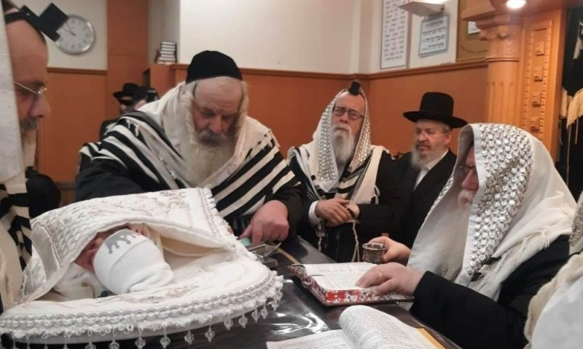HaRav Aharon Eckstein performs a bris in Antwerp.

A draft policy document issued by the Crown Prosecution Service (CPS) classifies male circumcision as a potential form of child abuse—placing a core Jewish mitzvah alongside practices such as exorcisms and forced marriage.
The guidance appears in a draft CPS framework addressing so-called “honour-based abuse and harmful practices.” While the document acknowledges that male circumcision is not explicitly illegal in England and Wales, it asserts that the procedure “may be a form of child abuse or an offence against the person” if deemed painful or harmful.
“This is not a technical clarification. It is a moral judgment,” said Jonathan Arkush, former president of the Board of Deputies of British Jews and co-chair of Milah UK. Arkush called the draft wording “deeply misleading,” warning that it reframes a foundational mitzvah as an inherently abusive act.
“To suggest that circumcision itself is a harmful practice is pejorative and profoundly incorrect,” he said.
The CPS document was drafted amid renewed scrutiny following a small number of tragic cases in which infants died after improperly performed circumcisions. According to the UK Office for National Statistics, seven deaths since 2001 have listed circumcision as a contributing factor. Most involved severe bleeding after procedures carried out outside regulated settings.
Jewish leaders do not dispute that negligence or malpractice must be addressed. What they fiercely reject is the implication that the religious act itself is suspect.
“In the Jewish community, circumcision is performed under stringent standards by trained and experienced practitioners,” Arkush said, adding that complications are “vanishingly rare.” He emphasized that no Jewish man he has encountered considers himself harmed by the ritual.
Muslim organizations echoed the concern. The Muslim Council of Britain warned that while safeguards and accreditation are necessary, “male circumcision is a lawful practice with recognized religious and cultural foundations and should not be characterized in itself as child abuse.”

The Challenge for Every Jew
to Turn the “Water” in their Daily Lives into “Blood”
From the Teachings of the Lubavitcher Rebbe
Rabbi Menachem Mendel Schneerson, Zt”l
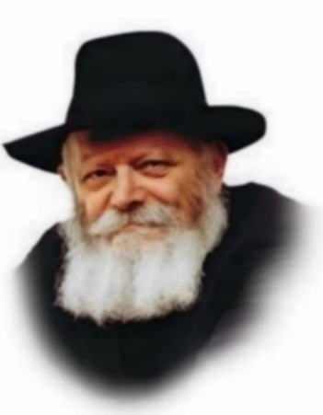
One of the main reasons that the Exodus from Egypt occupies such a central role in Judaism (we mention it daily in our prayers) is that this original exodus symbolizes the daily spiritual exodus that must take place in the life of a Jew. The Hebrew word for Egypt, "Mitzrayim," comes from the root word "Meitzar," meaning limitations and obstacles. It is up to every individual to liberate himself from his own internal limitations and boundaries, thus freeing his G-dly soul to express itself and seek spiritual fulfillment.
This week's Torah portion, Vaeira, tells of the very beginning of the events which led up to the Jews' triumphant liberation from bondage. By studying the circumstances of the Egyptian exodus, we see how we can apply these lessons to our own personal and spiritual journey as well.
The first plague to afflict the Egyptians was blood; every drop of water in the land was affected. Therefore, the first step toward spiritual liberation must also somehow be connected with transforming "water" into "blood."
Water symbolizes tranquility, coldness, and lack of emotional excitement. Blood, on the other hand, is a symbol of warmth, enthusiasm and fervor. The Torah asks every Jew: Do you truly want to leave "Egypt," to overcome your self-imposed limitations? The first thing you must do is turn your "water" into "blood." Transform your apathy and inertia into enthusiasm and love of Torah and mitzvot (commandments). Infuse your life with a warmth and fervor directed toward G-d and holiness.
A person may claim, "Is it not enough that I simply perform the mitzvot, study Torah, and avoid that which is forbidden? Am I not a good Jew even if I don't feel any enthusiasm for what I do?"
Chasidic philosophy explains that coldness and apathy are the source of all evil. When one is cool toward something, it means that he is totally uninterested in it. We see that when something truly close to the heart is mentioned, our pulse quickens and we "warm" to the subject. Coldness signals the mechanical performance of the commandments and leads to eventual spiritual deterioration.
The first action to be taken toward spiritual liberation is to replace our lukewarm dedication to Judaism with warmth and enthusiasm. We should be at least as equally enthused about Judaism as we are about other facets of our lives.
One of the practical ways this expresses itself is when we perform a mitzva in a particularly nice way. The desire to enhance our observance leads to our observing the precepts of Judaism out of love. This, then, is the first step towards going out of our own personal Egypt and ending our collective exile.
Adapted from the works of the Lubavitcher Rebbe

Reprinted from the Parashat Vaera 2002/5763 edition of L’Chaim, a publication of the Lubavitch Youth Organization. Adapted from Likutei Sichoth of the Lubavitcher Rebbe.

Rav Avigdor Miller on
How Jews Can Learn
From Iran’s Troubles

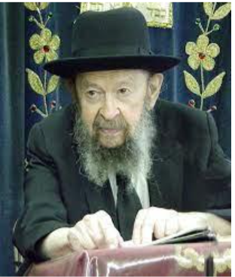

QUESTION: Regarding the recent Iranian earthquake, how does the following statement from the Ayatollah Khamenei reflect on the Iranian people? ‘We have considered the natural disaster as a divine test and we submit ourselves to the will of Allah?
ANSWER: I’ll tell you. I’ll formulate the question a little differently. ‘What should we learn from the earthquake in Iran?’ I’ll say that.
אין פורענויות בא אלא בשביל ישראל – No misfortunes come upon the world except for the sake of Yisroel, and Rashi says ליראם – to make Yisroel afraid. We should learn that there is a such a thing as retribution. Hakadosh Baruch Hu brings retribution. And because of that we should be afraid and try to avoid anything that would make us chalilah worthy of retribution.
Now why should we consider the Iranians deserving of retribution? The answer is because they were persecuting the Jews. No question what they were doing lately, keeping them in prison, not allowing them to depart; no question about that.
The hatred [of the Iranians] towards the Jews in Eretz Yisroel — I’m not talking about Zionist things but there are Jews in Eretz Yisroel. The Iranians are full of hatred towards Jews and that’s enough of a reason.
The fact that there are other anti-Semites in the world? Wait. Don’t give up. Things will happen to them too. Be patient.
But the main purpose is not to rejoice in their misfortune; the main purpose is to think about ourselves. When we think about what’s happening in this country, the wickedness that’s taking place here and many Jews are participating in this wickedness, you have to be afraid. And the more we’re afraid, the better off we are.
(June 1990)

Reprinted from the website of Toras Avigdor.

An Open Letter to
Candace Owens
By Rabbi Zecharia Rubin



Dear Ms. Owens,
I am the grandchild of Holocaust survivors. I didn’t learn about hatred from a textbook, I watched it unfold in real life with my grandmother who lived in our home. I watched her suffer every single day from PTSD and depression. I saw her distrust in everyone around her.
Her fear didn’t end when the war ended. It was carried home, passed down, and absorbed quietly by the next generations. Antisemitism is not abstract for me. It’s personal and ongoing.
Your recent statements, in which you promoted false claims about Jews controlling the transatlantic slave trade and spreading conspiracies about individuals like Ben Shapiro and the State of Israel, are deeply concerning. These are not harmless opinions; they are echoes of centuries-old lies that have fueled discrimination, harassment, and violence against my community.
You say that the Jews control everything. Was that true when my grandfather hid in the forests protecting his family and others from murderous Nazis? Was it true when my grandmother was placed in a concentration camp for the simple crime of being Jewish? Were my grandparents in control when they celebrated their wedding in the mess hall at the Displaced Person's camp wearing recycled wedding gown and suit, daring to build a family even though they had absolutely nothing?

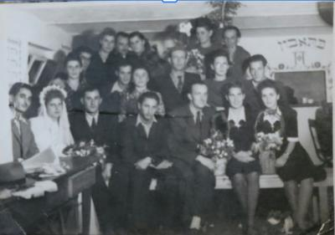
My grandparents, Helen and Joseph Wasserman, seated second and third from the left in the front row, in the mess hall in the DP Camp

Ms. Owens, who was in control when Jews were massacred on October 7th or more recently on Bondi Beach? Who is in control when antisemitic events rise throughout the world?
By sharing these fallacies, you are fanning the flames of antisemitism. Today, nearly half of American Jews report avoiding at least one ordinary behavior, not attending events, not wearing visible symbols, not posting online, because of fear. After the Hamas attacks in 2023, 78% of American Jews said they felt less safe in the United States itself. Antisemitic incidents rose 139% from 2022 to 2023. This is not paranoia. The data reflects this reality, and you are contributing to this unbridled Jew hatred.
Antisemitism often doesn’t first appear as violence. It starts with words, lies, and insinuations. It’s being told, “That’s not really antisemitic.” It’s being expected to justify your existence, or watching hatred dismissed as politics. It’s hearing claims rooted in centuries-old propaganda, like those you cited, repeated in public forums.
But history shows how quickly words can escalate into actions. Six million Jews were murdered during the Holocaust because others decided they were different, dangerous, and deserving. Lies can be lethal.

I Refuse to Let Your Hatred Affect Me
Ms. Owens, I do not expect you to change, but your words will not change me either. I will not hate, as you claim all Jews do. I will do my best to be a light unto the nations—through learning and teaching, through acts of kindness and justice, through building rather than destroying. I will continue to live openly as a Jew.
We are a people shaped by memory and survival, who have endured exile, persecution, and loss, yet have continually chosen life. Across history, the Jewish people have helped shape ethical thought, advanced medicine and science, enriched culture and literature, strengthened education, and stood at the forefront of humanitarian efforts. We build families and communities, establish institutions, heal the sick, pursue knowledge, and strive to repair the world.
Even as you project your hate onto us, we continue to contribute, to create, and to hope, affirming through our lives that resilience, morality, and compassion are stronger than prejudice. Your words cannot erase our history. We will continue impacting the world with resilience and love.

Reprinted from the current website of aish.cm

Thoughts that Count
for Our Parsha

These are Aaron and Moses...These are Moses and Aaron (Ex. 6:26, 27)
Aaron, the first kohen (priest), embodied the proper worship of G-d, and by extension, symbolizes prayer in general. The job of the kohanim was to offer the sacrifices in the Holy Temple in Jerusalem. In our time, when we have no Temple, prayer must take the place of these sacrifices. Moses, on the other hand, epitomized and symbolized Torah study. The juxtaposition of the two names and their repetition in the reverse order teaches us that there are times in our daily lives when one aspect takes precedence over the other. Sometimes we stress prayer as a preparation for performing mitzvot (commandments) and studying Torah, and sometimes we study first in order to pray more effectively. (The Lubavitcher Rebbe)

And I will take you out from under the burdens of Egypt (Ex.6:6)
It is far easier to physically take the Jews out of galut (exile) than it is to remove the inner galut from within every Jew. (Rabbi Yaakov Shimshon of Shpitovka)

And I will bring you out from under the burdens of Egypt, and I will deliver you from their bondage (Ex. 6:6)
Would it not have made more sense for G-d to mention the release from bondage first, and then promise the Jews that they would be redeemed? Were they not first physically released from slavery before they left Egypt? However, it was only after the fact, after the Jews had actually left the Egyptian exile, that they could appreciate precisely how bitter it had been. Only then could they truly understand what it meant to be delivered from bondage. (Tiferet Uziel)

Behold, the Children of Israel have not hearkened unto me (Ex. 6:12)
What does G-d answer when Moses complains that the Jews will not listen to him? "These are the heads of their fathers' houses." The Jewish people were not to blame for their inattention to Moses' message; the fault was that of the Jewish leaders, who were closed to the idea of the Redemption and unwilling to spread the message. (Ohr Hachaim)

Reprinted from the Parashat Vaera 2002/5763 edition of L’Chaim, a publication of the Lubavitch Youth Organization.
Julie Menin Coasts to Victory for Speaker of the NYC City Council

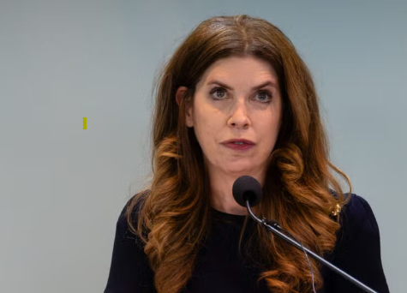
Julie Menin

- Julie Menin was unanimously elected speaker of the City Council on Wednesday. The first Jew in the role and a centrist Democrat, she will be a significant check on Mayor Zohran Mamdani, who promised to “govern as a democratic socialist.”
- Menin’s mother and grandmother survived the Holocaust hiding in a cellar in Hungary, and her grandfather was killed.
- In her inaugural speech, Menin celebrated the new frontiers she shared with Mamdani. “We live in a day with the first Muslim mayor of New York City and now the first Jewish speaker of the Council serving at the same time,” said Menin.
- But the two have strong ideological differences. Mamdani sought to thwart her bid in favor of a more progressive candidate, Politico reported, and Menin declined to endorse him for mayor.
- Menin invited Rabbi Joseph Potasnik, the head of the New York Board of Rabbis, to deliver her invocation. The organization recently criticized Mamdani for revoking two of his predecessor’s executive orders related to defining antisemitism and banning boycotts of Israel. (Potasnik sat on one of Mamdani’s transition committees.)
- Menin herself called Mamdani to say she was “extremely concerned” about repealing the orders, according to the New York Post.
- She referenced a recent anti-Zionist protest outside a Manhattan synagogue in her speech, saying, “We cannot let what happened outside Park East Synagogue ever happen again, at any house of worship.” Mamdani suggested that the event, which promoted migration to Israel, misused a “sacred space.”
- But Menin also said that Mamdani seemed open to a bill she plans to pass, which would prohibit protests in a perimeter around houses of worship and schools. Gov. Kathy Hochul said she will announce a similar statewide measure on Tuesday.

Reprinted from a recent JTA posting on the Jewish Week.

Orthodox Jewish Senior Judge to Preside Over Nicolás
Maduro Case in Manhattan

Ninety-two-year-old Senior United States District Judge Alvin K. Hellerstein – an Orthodox Jew – will preside over the criminal case against Venezuelan President Nicolás Maduro in the U.S. District Court for the Southern District of New York, placing one of the most consequential international prosecutions in recent years in the hands of one of the federal judiciary’s most senior jurists.
Judge Hellerstein, who has served on the Manhattan-based federal bench for more than a quarter-century, is among the oldest active federal judges in the country. He took senior status in 2011 after being appointed to the court in 1998 and continues to hear major cases in the Southern District, which is widely regarded as the most powerful federal prosecutor’s office in the United States.

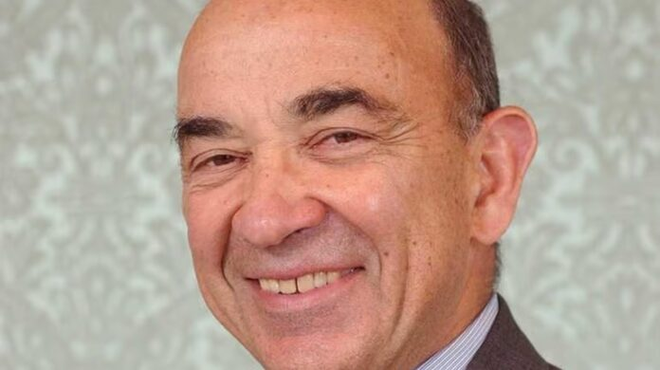
United States District Judge Alvin K. Hellerstein

The assignment has drawn attention not only because of Hellerstein’s age and judicial stature, but also because he is an Orthodox Jew, a personal background that has long been publicly known but is rarely highlighted in connection with such a high-profile international criminal case.
Maduro faces sweeping federal charges related to narcotics trafficking, terrorism-linked offenses, corruption, and other serious crimes. The case has major geopolitical implications and has been closely watched since the charges were first unsealed by U.S. prosecutors several years ago. With Maduro now in U.S. custody, the proceedings are expected to move forward in Manhattan federal court.
Judge Hellerstein brings extensive experience with complex, politically sensitive, and historically significant litigation. Over the years, he has presided over major financial cases, terrorism-related litigation, and nationally prominent civil actions, including consolidated lawsuits arising from the September 11 attacks. He is known for detailed rulings, firm courtroom management, and a methodical approach to evidentiary and procedural issues.
Born in New York City in 1933, Hellerstein earned his undergraduate and law degrees at Columbia University before serving in the U.S. Army Judge Advocate General’s Corps. He later spent decades in private practice before joining the federal bench, where he quickly became a central figure in the Southern District’s docket.
In addition to his judicial career, Hellerstein has long been active in Jewish communal and educational life, being a shomer Torah umitzvos while serving in senior public office. His role in the Maduro case places that personal background alongside one of the most prominent prosecutions ever handled by the Southern District of New York.

Reprinted from the January 3, 2025 website of Yeshiva World News

Williamsburg Shomrim Use Sophisticated Technology to Recover Lost Tefillin

Williamsburg Shomrim volunteers recovered a lost pair of tefillin last week after an hours-long, multi-day search that combined technology, persistence, and on-the-ground coordination, ultimately returning the tefillin to their owner and preventing a costly loss.
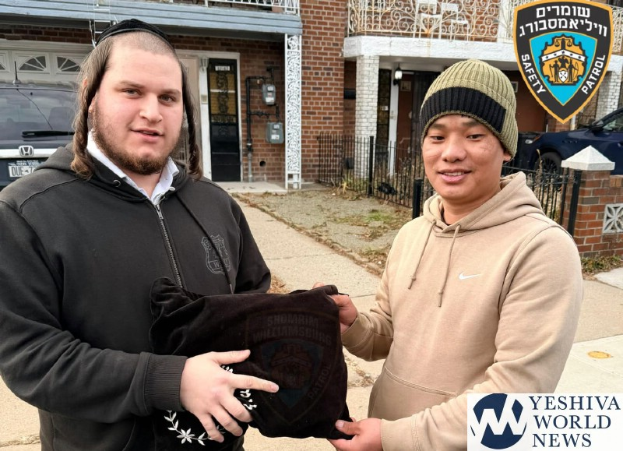
According to Shomrim, the call came in after a resident reported that a pair of tefillin had been left behind in a car service vehicle. Shomrim’s IT and dispatch units immediately launched an effort to identify and locate the driver.
Volunteers were able to obtain the vehicle’s license plate number and traced it to an address in Queens. A Shomrim member was dispatched to the location and waited for several hours in an attempt to make contact with the driver, but initial efforts were unsuccessful.
Refusing to abandon the search, Shomrim escalated the response by placing a License Plate Recognition (LPR) alert on the vehicle. The strategy paid off the following day, when the system flagged the car entering the Williamsburg area.
Shomrim units were immediately dispatched to the location. When volunteers approached the driver, he confirmed that the tefillin were in his home in Queens. Shomrim members then traveled back with him to retrieve the tefillin, after which they were returned to their grateful owner.

Reprinted from the website of Yeshiva World News.

What Did Moses Look Like?
By Leibel Kahan


Art by Sefira Lightstone

As the greatest prophet in history, Moses is remembered for leading the Jews out of Egypt and descending Mount Sinai with the Tablets.
Artists, most notably Michelangelo, have envisioned him with a flowing white beard (and even horns!), but what did he really look like?
The Torah and our Sages offer a few deliberate clues, each revealing something essential about who Moses was and how he carried his role as a leader and a prophet.
Radiance
The first glimpse comes at the very beginning of his life. When Moses is born, the Torah says, “She saw him, that he was good”¹ — a phrase that, according to the Talmud, points to a visible light that filled the house.² The Talmud understands this from the same wording used to describe Creation: “and G-d saw the light, and it was good.”³
Decades later, after descending Mount Sinai with the second set of Tablets, the Torah records that “the skin of his face was radiant, since he had spoken with G-d.”⁴ The light on Moses’ face was so intense that the Israelites were afraid to approach him, and Moses was forced to place a veil over his face when speaking to them.
No Horns!
This moment also explains one of the most enduring misconceptions about Moses’ appearance. The Hebrew word karan describes rays of light emanating from his face. When mistranslated as keren, “horns,” it led to mistaken depictions, such as Michelangelo’s statue. In the Torah’s own telling, however, the image is not of horns but of a man visibly marked by his encounter with the Divine.

An Imposing Figure
Beyond his shining countenance, the Sages also describe Moses as physically imposing. The Talmud relates that Moses stood ten cubits tall⁵ — a detail that helps explain how he was able to erect the Tabernacle on his own.⁶ To understand whether this is to be taken literally, see My Kid Thinks Moses Was Ten Feet Tall.
That strength remained with him until the very end of his life. When Moses passed at the age of 120, the Torah testifies that “his eyes were undimmed and his vigor unabated.”⁷ Medieval commentator Rashi explains that even after his passing, Moses’ face did not change and his body did not decompose.
In other words, Moses did not weaken with age, nor did his physical presence diminish at life’s end. From the radiance that filled the house at his birth to the light that shone from his face after Sinai, the Torah presents a figure whose body fully reflected his role. Yet these details are shared sparingly, never as objects of admiration in themselves, but only where they help us understand the life of the man who served as the faithful conduit between G-d and the Jewish people.

Reprinted from the current website of Chabad.Org

Footnotes
1. Exodus 2:2. 2. Sotah 12a. 3. Genesis 1:4. 4. Exodus 34:29.
5. Berachot 54b. 6. Midrash Tanchuma, Vayakhel 7. Deuteronomy 34:7.

